**1 INTRODUCTION**

1.1 Overview

* Name of host.
* It is a letter that is written to invite individuals to a specific event.
* Our organization will be venerated to welcome you as a guest.
* An invitation is a written or spoken request to come to an event such as a party, a meal, or a meeting.

1.2 Purpose

* A formal letter addressed to a dignitary or prominent official inviting them to attend a particular event.
* They are used in formal events such as cocktails,weddings,etc.
* To invite your guests and to give more detail about your event.

**2 Problems Definition & Design Thinking**

2.1 Empathy Map

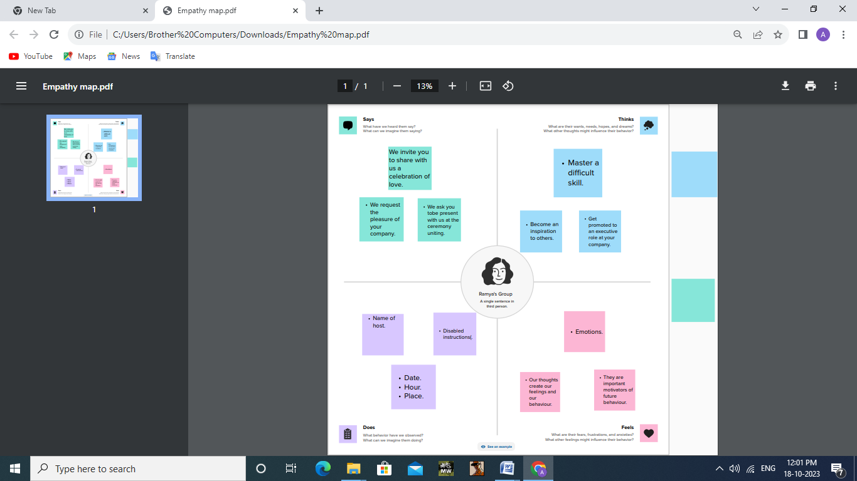

2.2 Ideation & Brainstorm Map

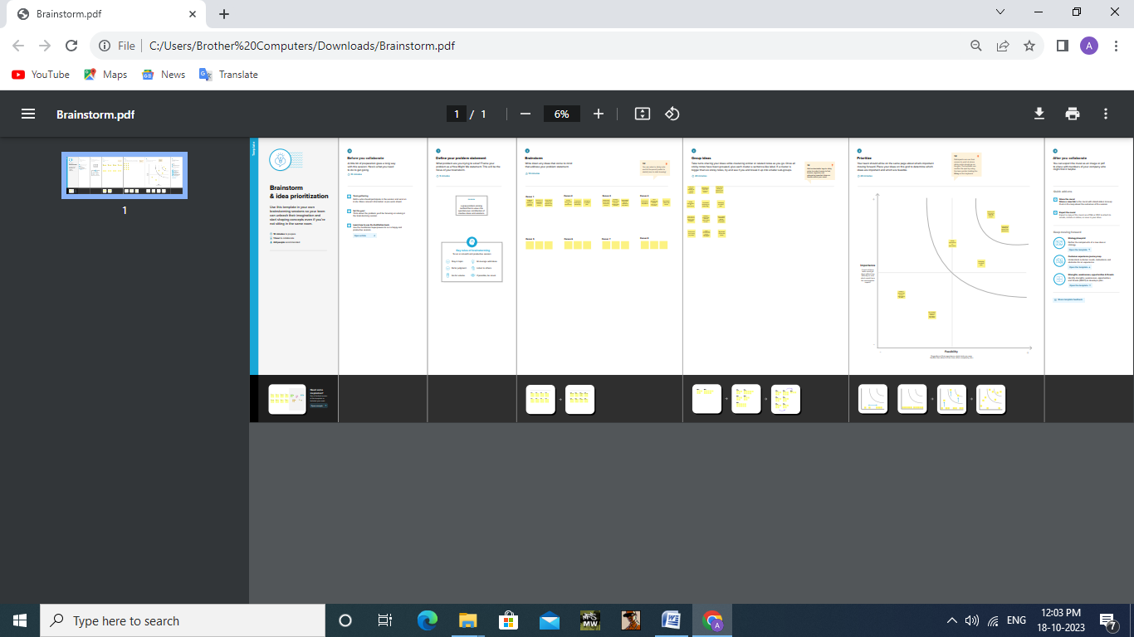

**3 RESULT**

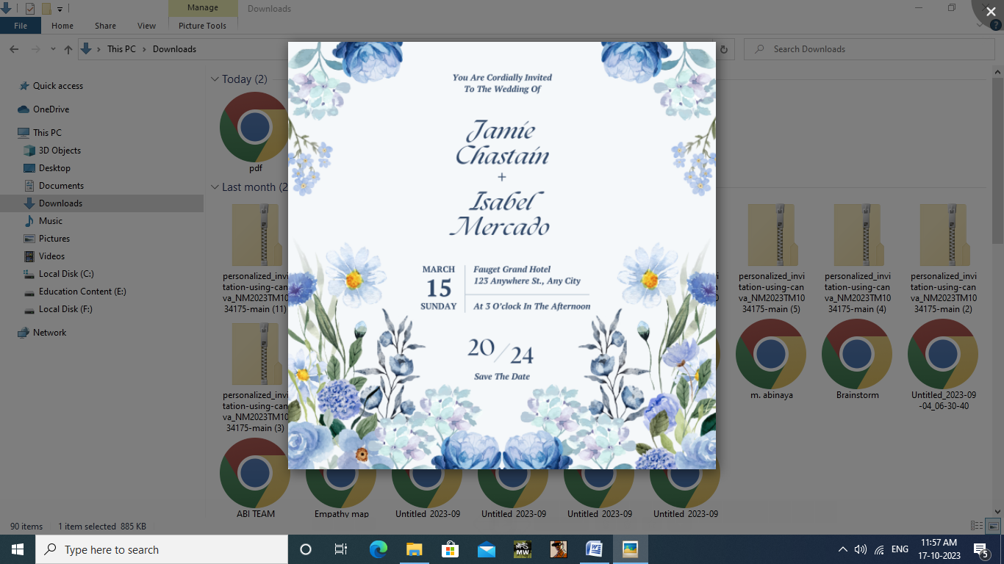

**4 ADVANTAGES & DISDVANTAGES**

Advantages:

* To make it personal.
* To be informative.
* To be memorable.
* To create a sense of anticipation.

Disadvantages:

* Those who like to save the invitation as a souvenir won’t have one.
* Privacy issues.
* Reach limitation.
* Cost of implememtation.

**5 APPLICATION**

One of the best tools available for you is InDesign- this vector graphics lets you work with a blank canvas to create any kind of invitations using numerous shapes,effects, and other interactive elements.

**6 CONCLUSION**

An invitation to offer becomes a contract only when the sellerextends an offer to the buyer. The key distinction lies in the term “invitation”. It signifies an invitation to any potential buyer to make an offer for the goods or services sold.